**Experimental and numerical analysis of thermal switch operation**

In this paper, a millimetre-scale oscillating gadolinium thermal switch is constructed using commercially available materials, with steady-state switching ratio of rswitch = 2,3. The thermal switch uses electrostatic forces for actuation and makes thermal contact between the heat source and the heat sink when in the ON state, and breaks contact when in the OFF state. In the ON state when the thermal switch is oscillating the Gd plate transfers heat, while in the OFF state, the Gd plate does not oscillate and heat is transferred via parasitic conduction through air gap and device’s housing. In this paper, we experimentally investigated the behaviour and switching ratio of the thermal switch under different conditions and demonstrated its ability to actively control the heat flux in low power density applications at room temperature. Later, the performance of the device is predicted theoretically using the online simulation tool TCC builder and compared the results with experimentally obtained values.

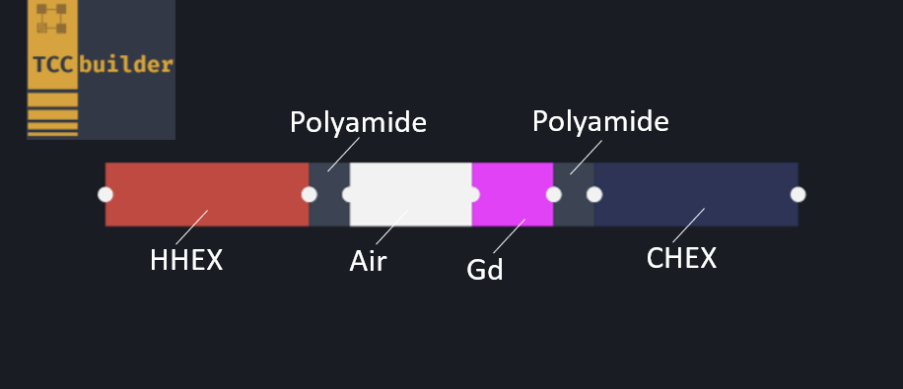

**Figure 1**: Device with thermal switch as presented in TCC builder.

**Eksperimentalna in numerična analiza delovanja toplotnega stikala**

V prispevko smo predstavili gadolinijevo toplotno stikalo s preklopnim razmerjem rts = 2,3. Toplotno stikalo je bilo vzbujano z elektrostatičnimi stilami in je vzpostavljalo stik s hladnim in toplim prenosnikom toplote, ko je bilo v vklopljenem stanju. Ko pa je bilo toplotno stikalo v izklopljenem stanju, pa je bil stik prekinjem. V vklopljenemu stanju, ko toplotno stikalo oscilira, Gd plošča prenaša toploto, medtem ko v izklopljenem stanju Gd plošča miruje. Pri tem nastopijo toplotni dobitki proti hlademu prenosniku toplote, zaradi prevoda toplote preko zračne reže ter prevoda toplote preko 3D natisnjenega ohišja naprave. V tem prispevku smo eksperimentalno raziskali delovanje in preklopno razmerje toplotnega stikala pod različnimi pogoji in pokazali zmožnost aktivnega nadzora toplotnega toka v aplikacijah z nizko gostoto moči. Nadalje smo delovanje naprave teoretično analizirali s pomočjo spletnega simulacijskega orodja TCC builder ter primerjali rezultate z eksperimentalno dobljenimi vrednostmi.